
VICTORIA JUNIOR COLLEGE

JC2 PRELIMINARY EXAMINATION 2026

H2 GEOGRAPHY 9173/01
Paper 1

INSERT 3 hours

READ THESE INSTRUCTIONS

The Insert contains all the Resources referred to in the questions.

This document consists of 8 printed pages.
Resource 1A for Question 1
Uranium production by country in 2018 (in tonnes)
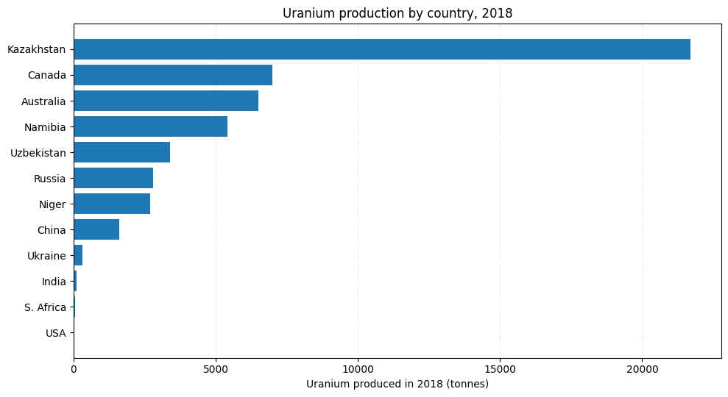
Resource 1B for Question 1
Contribution of uranium to GDP by country (2018)
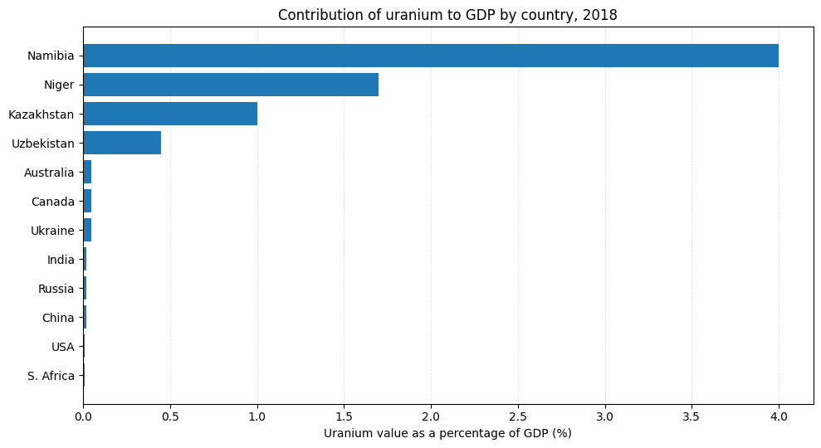

Resource 2 for Question 1
Uranium Production in Niger
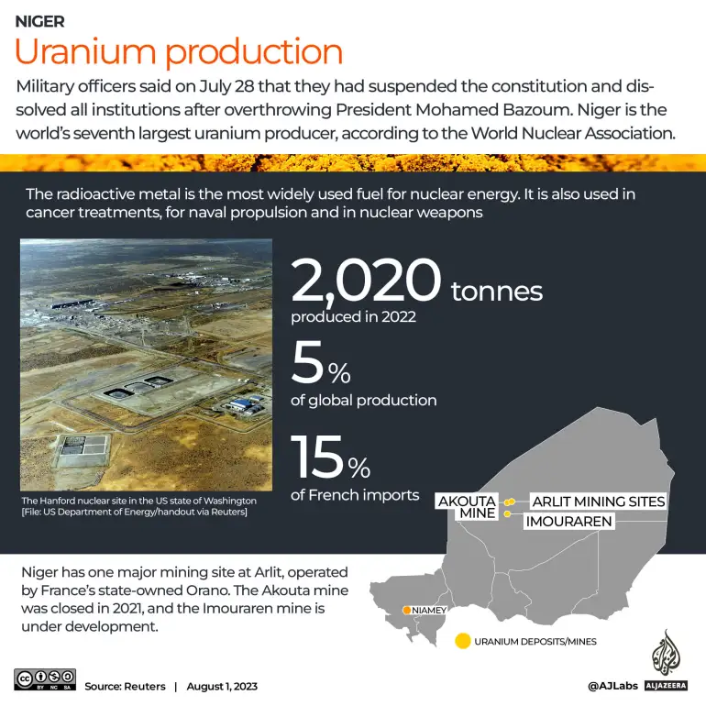

Resource 3 for Question 1
Spatial organization of Orano, French energy based TNC
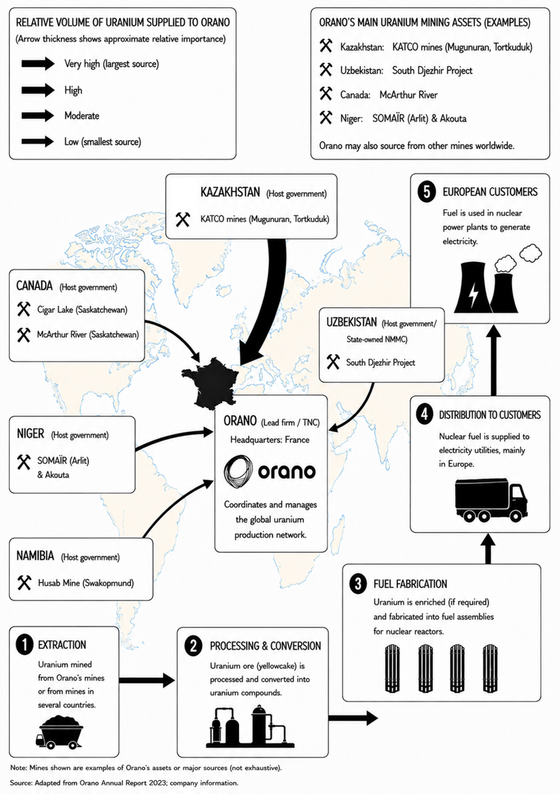

Resource 4 for Question 2

Path of Typhoon Bavi in July 2026

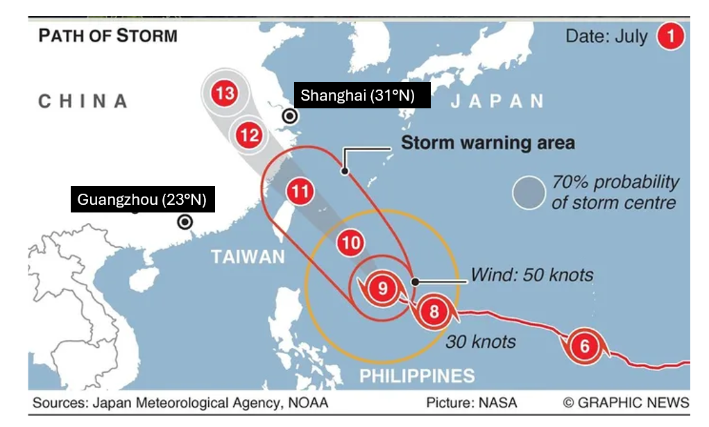

Resource 5 for Question 2

Adapted article excerpt on landslides in Mindanao, Philippines in July 2026

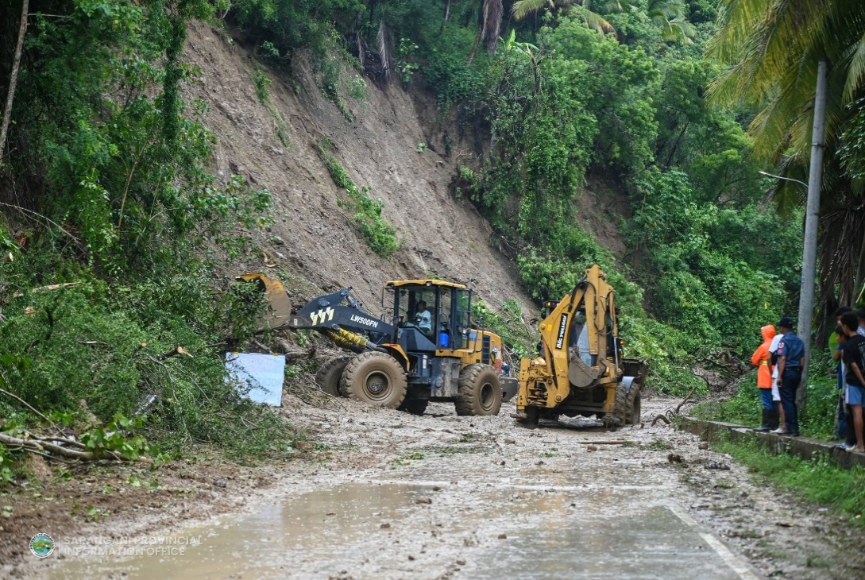

Debris being cleared from roads after landslides in Mindanao

At least 13 people were killed, and eight others remained missing after landslides as Typhoon Inday (international name: Bavi) struck parts of Mindanao on Friday between 3 a.m. and 4 a.m. Authorities said that continuous heavy rains since Thursday triggered the collapse of large sections of hillsides, burying several houses built on the slopes.

Resource 6A for Question 2

Map of the Yangtze River Delta, China

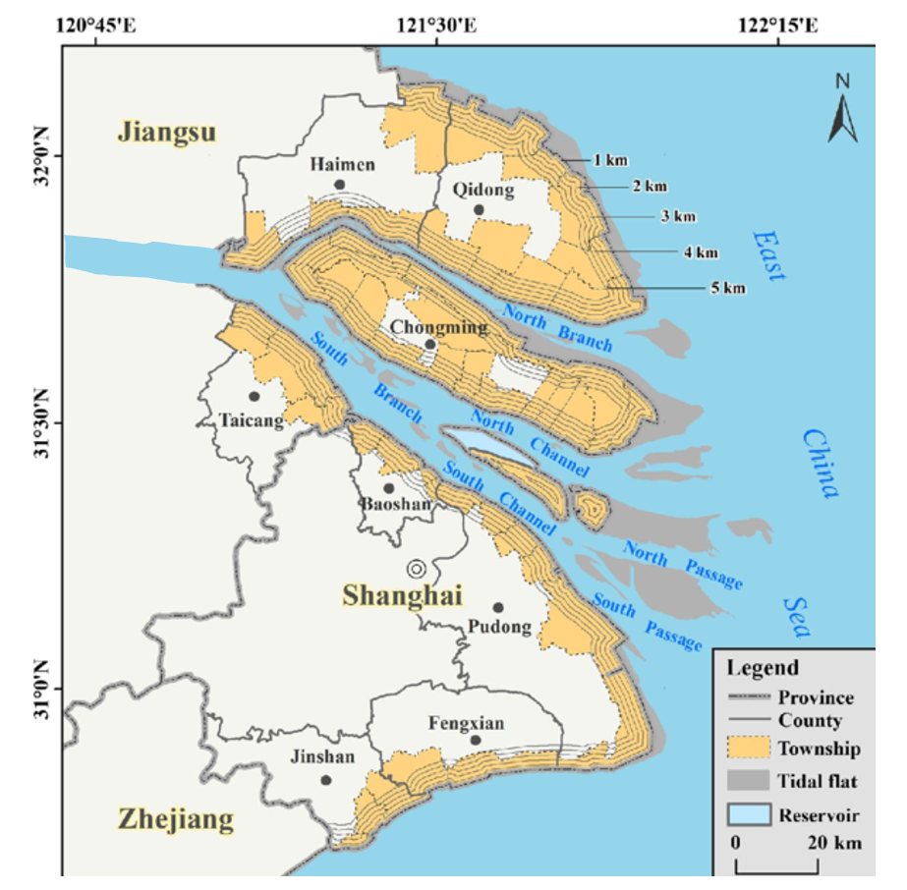
Yangtze River

Note:
- The gray lines along the coastline indicate the distance from the sea (1-5km).
- Tidal flats are coastal wetlands that form where rivers and tides deposit fine sediments such as mud, sand and clay.

Resource 6B for Question 2

Satellite image of the Yangtze River Delta, China

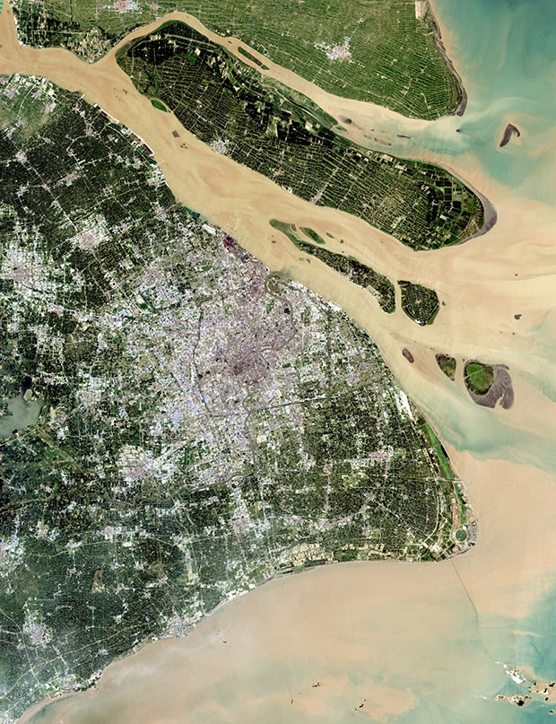

Sources

Resources 1A & 1B | Adapted from http://large.stanford.edu/courses/2022/ph240/courtney1/
Resource 2 | https://www.aljazeera.com/news/2023/8/1/eu-sees-no-uranium-supply-risks-to-nuclear-production-after-niger-coup
Resource 3 | Adapted from Orano’s Annual Company Report 2023
Resource 4 | https://iol.co.za/news/world/2026-07-09-china-braces-for-biggest-storm-in-years-gargantuan-typhoon-bavi/
Resource 5 | https://newsinfo.inquirer.net/2261614/13-dead-8-missing-in-mindanao-landslides
Resource 6A | Wang, X, et al. (2022) Spatial heterogeneity of land use along the coast of the Yangtze River Delta and implications for exposure assessment to erosion hazard, Anthropocene Coasts, 5(10).
Resource 6B | https://scenariojournal.com/article/yangtze-river-delta-project/

